Nirvana Deepu C R
C/o Smt Saraswathi, No-25/1, 3rd Cross, Nagappa block, Srirampura, Bangalore-560025.
Cell:-7795216376,
Email ID: nirvana_deepu@yahoo.co.in, nirvanadeepu@gmail.com

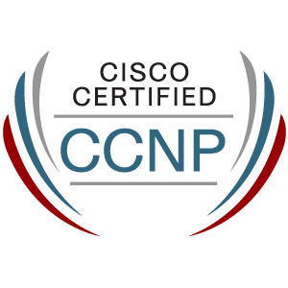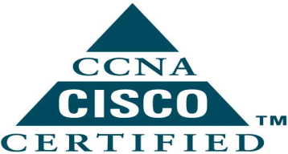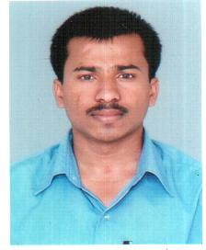

Summary:
Careers involving challenging opportunities in organization, which will let me learn and grow while contribute to the growth of the organization using my knowledge and skills.

Summary of skills:

IP Routing:
TCP/IP, RIP, IGRP, EIGRP, OSPF, BGP, HSRP, VRRP, GLBP,VRF.

IP Switching:
VLAN, VTP, STP, RSTP, LACP, PagP, PORT SECURITY.

Technologies:
10/100 Ethernet, Gigabit, ISDN, Leased Lines, QOS, NAT Policy, Access-List, MPLS, IP TELEPHONY.

Familiar with Cisco ASA 5500 ,PIX 500 firewalls, Cisco 1800, 1900, 2800, 2900, 3500, 7200 routers 2900, 3750 switches ,Hp Procorve & D-Link switches.

Implementing inter VLAN routing L2&L3, Network Monitoring, Restoration, IOS Up gradation, Password Recovery, TT resolving and analysis.

Professional Certification:

- CISCO CERTIFIED NETWORK ASSOCIATE (CCNA) (CSCO11761771).
- IP ROUTING [CCNP 642-902] CERTIFIED.
- Pursuing Switching & Troubleshooting [CCNP].

Professional Summary: 3 Year 10 Months of IT Experience.

- Working for NATIONAL INFORMATION CENTER though WIPRO INFOTECH PVT LTD as ASSOCIATE NETWORK ENGINEER from 29 may 2012 to till.

Responsibilities:

- Working on NOC of NIC, Managing and directing L1/L2 support of network connection at the various district courts and govt. offices all over Karnataka also carrying out LAN and server security in the network.
- Monitoring of links, Network Traffic using WHATS UP GOLD, SPECTRUM & MRTG tools.
- Configuration & Trouble shooting of Router, Switches & IP phones.
- Configuration of WIFI Router(AP) & WIFI Controller (WLC).
- Configuration of VPN over Broad band over 30 Districts in Linux & Windows server.
- Maintaining of DHCP & PROXY Linux Servers.
- Working on MCU to connect vedio conference(VC) of multiple location.
- Co-ordination with ISP, Vendors and District Field Engineers.
- Maintaining documentation of Network assets and vendors database.

- Worked for DSM INFOCOM PVT LTD as a NETWORK ENGINEER from 26th November 2010 to 25th May 2012.

Responsibilities:
- Commissioning the new links for newly opening sites.
- Configuration and Installation of Routers , Switches , IP Phones & WIFI Devices.
- Monitoring And Trouble shooting of routers using WHATS UP GOLD in NAP CENTERS.

- Replacement of Network Hardware Device like PowerSupply, Fantray, LineModule, WicCard.
- Coordination with Data center-DC, and Data Recovery Center-DRC, to resolve all connectivity and routing issues.
- Coordination with Telecomm Personals for Leased lines and ISDN BRI/PRI commissioning & Trouble shooting.
- Maintenance of leased line-LL, ISDN-PRI & E1 Circuits.
- Worked for BAJAJ ALLIANZS as a RENIWAL EXICUTIVE from 05th October 2009 to 08th April 2010.

Education:

Degree | Year | Institute | Board / University
B.E. in Computer Science  (1 to 8 sem) | 2008 | City Engineering College,  Bangalore. | V.T.U, Belgaum
XII | 2003 | Govt Junior college  Chikamagalur. | Karnataka PU Board,  Bangalore.
X | 2000 | Gov t H.S. school  Muguthihalli | Karnataka State Board,  Bangalore.

Hobbies:
- Listening Music,
- Surfing Net,
- Playing Cricket and Watching T.V.

Personal Details:

Name : Nirvana Deepu C R

Father’s Name : Rudresh H N

Sex : Male

Date of Birth : 3rd May 1985

Marital Status : Unmarried.

Mobile No : +91-7795216376

Permanent address : Ganesh deep nilaya
Jayanagar extn,
Chikamagalur-577101

Language Known : English, Hindi, Kannada.

Personal strength:

Analysis and design of various requirements, very good Logical Thinking ability, a high sense of adaptability, raising to the need of the hour and willing to work dedicatedly for an organization which rewards excellence and perfection.

Declaration:

I hereby declare that the above information furnished are true to the best of my knowledge and belief.

Place : Bangalore
Date : NIRVANA DEEPU C.R

